Key Proofreading Marks
Mark | Explanation | Examples
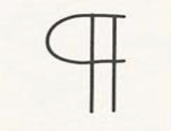 | Begin a new paragraph. Indent the paragraph | 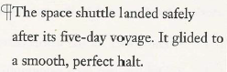
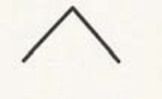 | Add letters, words, or sentences | 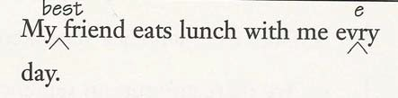
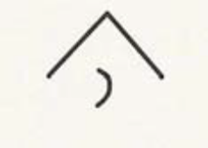 | Add a comma | 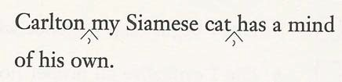
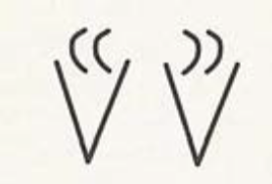 | Add quotation marks. | 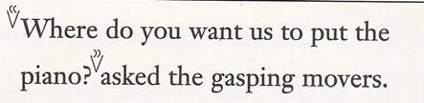
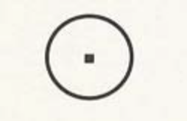 | Add a period | 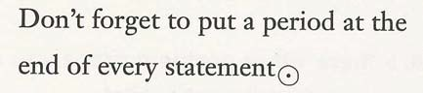
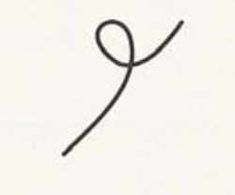 | Take out words, sentences, and punctuation marks. Correct spelling. | 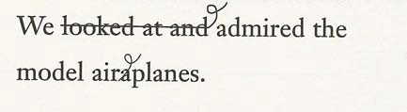
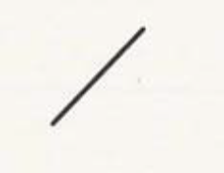 | Change a capital letter to a small letter. | 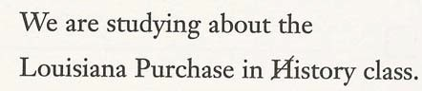
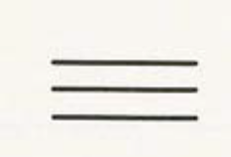 | Change a small letter to a capital letter. | 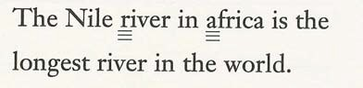
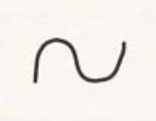 | Reverse letters or words. | 